**MASS EFFECT**

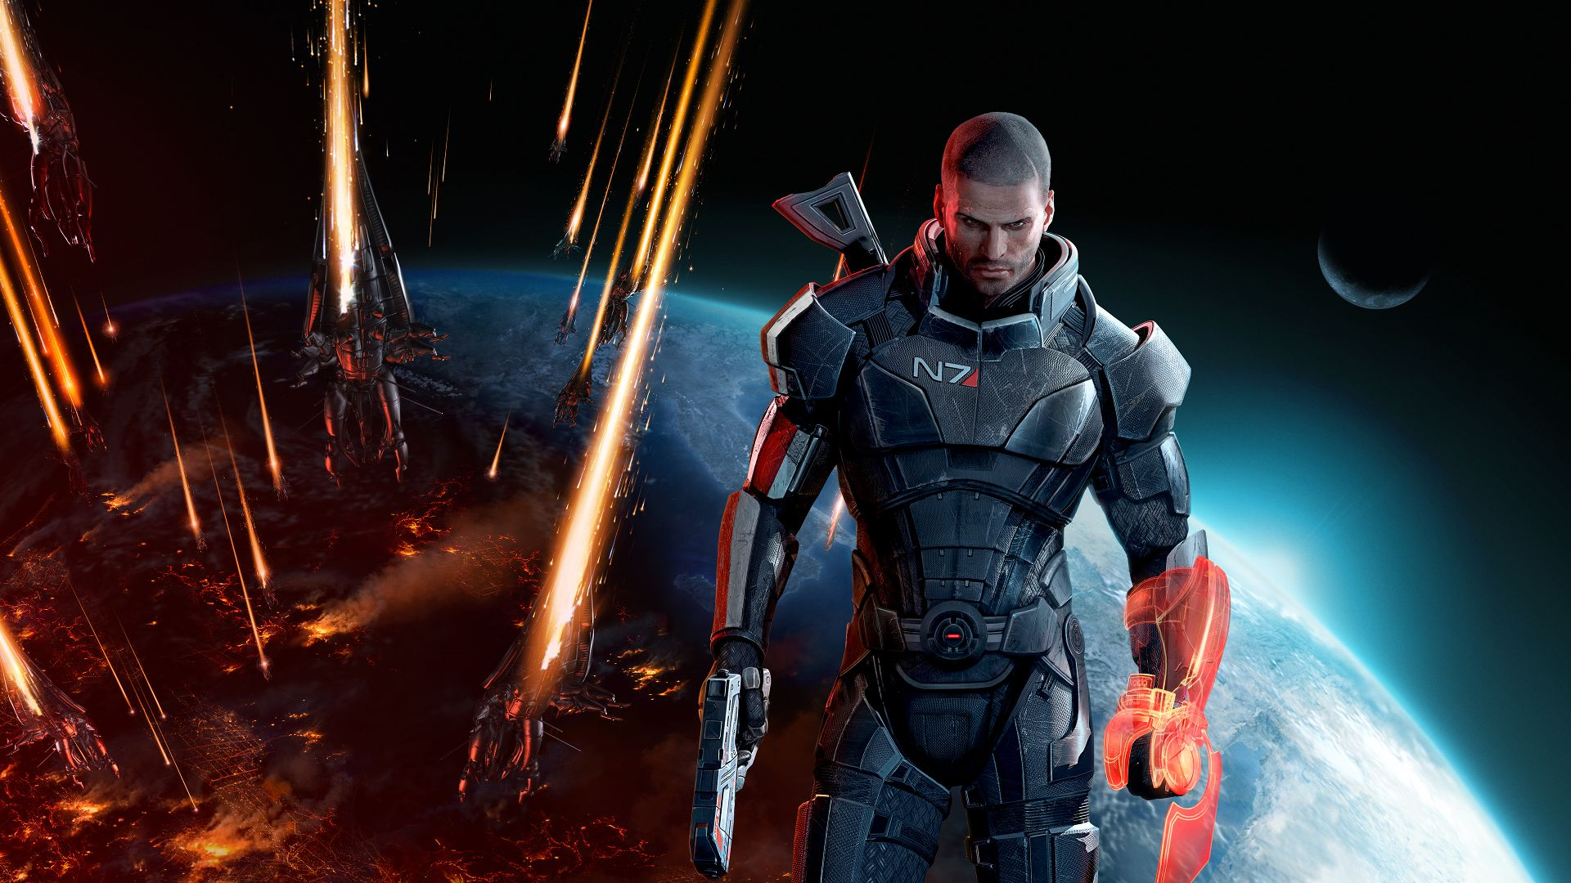

Image Sourcdgylabs.com

**BACKGROUND**



***Mass Effect*** is an [action role-playing](https://en.wikipedia.org/wiki/Action_role-playing_game) [video game](https://en.wikipedia.org/wiki/Video_game) developed by [BioWare](https://en.wikipedia.org/wiki/BioWare) and published by [Microsoft Game Studios](https://en.wikipedia.org/wiki/Microsoft_Game_Studios) and [Electronic Arts](https://en.wikipedia.org/wiki/Electronic_Arts). Originally released for the [Xbox 360](https://en.wikipedia.org/wiki/Xbox_360) video game console in 2007, it is the first game of the [*Mass Effect*](https://en.wikipedia.org/wiki/Mass_Effect) series.

The game takes place within the [Milky Way](https://en.wikipedia.org/wiki/Milky_Way) galaxy in the year 2183, where civilization is threatened by a highly advanced machine race of synthetic-organic starships. The player assumes the role of [Commander Shepard](https://en.wikipedia.org/wiki/Commander_Shepard), an elite human soldier who must stop a rogue agent from carrying out the machine race's galactic invasion. The gameplay requires the player to complete multiple [quests](https://en.wikipedia.org/wiki/Quest_(video_gaming)) that generally involve space exploration, squad and vehicular combat, and interaction with [non-player characters](https://en.wikipedia.org/wiki/Non-player_character).

Planned as the first chapter of a trilogy from the very beginning, *Mass Effect* was developed over the course of three and a half years and uses the [Unreal Engine 3](https://en.wikipedia.org/wiki/Unreal_Engine_3) as a groundwork. It was designed so that the player would assume the role of a central character that could make important decisions and impact the story of the game in numerous ways. The combat was designed to offer the tactics and customization of a role-playing game, but through a simpler and [real-time](https://en.wikipedia.org/wiki/Turns,_rounds_and_time-keeping_systems_in_games) [third-person shooter](https://en.wikipedia.org/wiki/Third-person_shooter) interface. In 2008 and 2009, two [downloadable content](https://en.wikipedia.org/wiki/Downloadable_content) packs that introduced new missions to the base game were released.

*Mass Effect* received critical acclaim from [video game publications](https://en.wikipedia.org/wiki/Video_game_journalism) and sold more than one and a half million copies by January 2008. Critics praised the game's [interactive storytelling](https://en.wikipedia.org/wiki/Interactive_storytelling) and cinematic design, but criticized its unbalanced combat mechanics and poor [artificial intelligence](https://en.wikipedia.org/wiki/Artificial_intelligence_(video_games)). The game received several year-end awards, including Best RPG at the 2007 [Spike Video Game Awards](https://en.wikipedia.org/wiki/Spike_Video_Game_Awards) and Roleplaying Game of the Year at the 2008 [Interactive Achievement Awards](https://en.wikipedia.org/wiki/Academy_of_Interactive_Arts_%26_Sciences). *Mass Effect* was [ported](https://en.wikipedia.org/wiki/Porting) to the [Microsoft Windows](https://en.wikipedia.org/wiki/Microsoft_Windows) and [PlayStation 3](https://en.wikipedia.org/wiki/PlayStation_3) platforms in 2008 and 2012, respectively. A sequel, [*Mass Effect 2*](https://en.wikipedia.org/wiki/Mass_Effect_2), was released in 2010.

A trilogy of games has been released, each continuing the previous game's story in chronological order. The *Mass Effect* series combines [action role-playing game](https://en.wikipedia.org/wiki/Action_role-playing_game) elements, with the main series games being in [third-person perspective](https://en.wikipedia.org/wiki/Third-person_perspective). The protagonist can use two AI-controlled squad members in battle, which usually consist of members he or she has recruited from various places and for various reasons, and taken onto the *SSV Normandy*, Shepard's stealth-recon starship. The player could make perspective decisions depending upon the situation. At these times, the player has multiple sets of dialogue choices with which to respond to NPCs, separated by tone. Starting from *Mass Effect 2*, the player can interrupt cut-scenes calmly or aggressively.